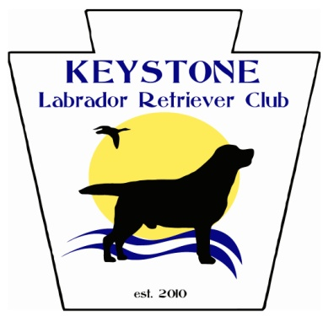

Show N Go All Breed/Mixed Breeds Obedience & Rally Match
Scheduled and timed by Pre-Entry Only
Saturday March 10, 2018
K9 Jym, Colmar, PA
$10 per entry
Closing date March 2, 2018
Any questions contact Karen Vare via e-mail svare@comcast.net
We are offering 6 rings starting at 8:30 am

Handler’s Name: _____________________________________
Email Address: ______________________________________
Dog’s Name & Breed:_________________________________
Jump Height:________________________________________

Obedience: Rally:
Novice:____________ Novice:_______________
Open:_____________ Advanced:____________
Utility:_____________ Excellent:_____________
Beginner Novice:___________

Please fill out a separate entry for each dog
Send entries to:
Karen Vare
1101 DeKalb Pike
Blue Bell, PA 19422
Make Checks payable to KLRC
If you need to be notified by mail please include a SASE.

